Breadboards

Subject: Circuits  Related Subjects: Electronics and Electrical Engineering | Grade Level(s): 4  Length of Lesson: | Type: Inquiry / Design / Project  Keywords:Circuits; Parallel; series

Lesson Overview
Using circuits for the second time, the kids will now deal with breadboards and logic gates. Breadboards are devices used to organize more complex circuitry. The side columns are connected by a conductor while the rows in the middle are each connected by a conductor.
- Parallel circuits are easier to make with breadboards
- Organization of a confusing topic can be accomplished for a student who has never dealt with circuitry
- More experimentation with circuits and switches

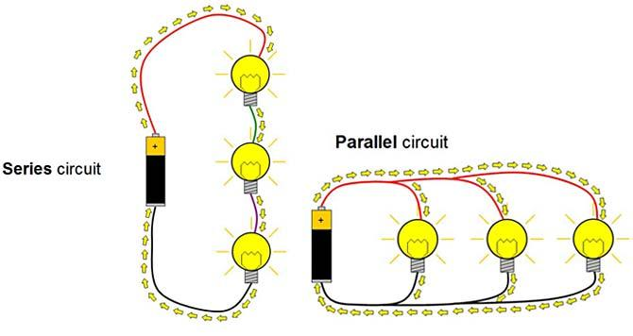
Hole pattern for a breadboard. Connections in the rows and columns are shown with extended lines.

Lesson Focus
What is the central question or phenomenon being investigated? What problem are they trying to solve?

Lesson Objective(s) | The students are to learn about parallel and series circuits using the breadboards.  - Learn about parallel and series circuits  - Understand their properties and the differing advantages  - Understand how breadboards work

Lesson Timing

5 minutes | Introduce the Lesson
30 minutes | ...

Materials | - Breadboards  - Battery holders  - Batteries  - LED lights  - Switches (NO, NC, SPST, SPDT)  - Blue lights  - Wires
Instructor Prep | - Step 1
Related Resources | - List related lessons/ppts etc available from USC or outside, trusted orgs

Lesson Plan

Introduction
Introduce students to the learning goals and make connections to past and present learning experiences. Stimulate interest and prompt students to identify their own questions about the topic. This can link the lesson to real world examples, introduce associated STEM careers, and assess their prior knowledge on the topic.

- Step 1

Procedure
- Students will each be given a breadboard and first construct a simple series circuit involving a battery, a light, and a switch
- Students will then get to build a more complex series circuit with multiple lights
- I will then have the kids reorganize their circuits to build a parallel circuit with and observe how the lights change in brightness
- If time allows, I will have the kids try to construct a true/false game using parallel circuits and the breadboard
  - Two LEDs will be on the right side of the board. Both will be connected to one end of the battery
  - The hole connecting the other side of the LEDs will have wires that travel around the backside of the breadboard to the other side, where they are each plugged into their own row.
  - The other wire to the battery will remain mobile, and can be connected to one the wires on the left side of the board by placing it in a hole in the row of choice.

Wrap-up
End the lesson with some final discussions about what students designed/discovered. Connect their activity back to the focus question/problem, real world examples, and STEM careers.

Also include notes about any special cleanup considerations

Lesson Background for Teachers

Suggested Real-World STEM Connections
- List possible related Role Models in STEM (with details and links to more reading). Give suggestions for examples of scientists/engineers who are from underrepresented groups in STEM in related careers.
- List related real-world engineering problems and examples

Lesson Variations and Options
Include descriptions of alternative methods or ways to present things.

Explanation
Describe the background concepts and explanations behind the lesson. This can be more in depth than a teacher/instructor would actually share with students.

Key Concepts and Vocabulary
- Word 1: Grade Appropriate Definition
- Word 2: Grade Appropriate Definition

Safety Notes
- Safety instruction

